STUDENT PERFORMANCE PREDICTION
Week 2 – EDA & Visualization Framework
Prepared by: Varun Kumar
Data Science Project

Revised to address evaluation feedback: concrete examples, numerical illustrations, diagrams embedded in the report, and more explicit feature-engineering and model-evaluation readiness.
Planning document • Illustrative values are assumptions, not experimental results.

1. Introduction to Exploratory Data Analysis (EDA)
Exploratory Data Analysis is the systematic process of inspecting, cleaning, summarizing, and visualizing a dataset before statistical modeling or machine learning. For the Student Performance Prediction project, EDA will identify data-quality issues and relationships among academic, attendance, behavioral, and demographic variables.
Project-scale planning example: the eventual dataset is planned as approximately 1,000 student records. This is illustrative. If 40 attendance values were missing, the missing-value rate would be 40/1,000 × 100 = 4%. The actual rate will be calculated after the dataset is obtained.
EDA can reveal missing values, duplicates, invalid ranges, skewed distributions, outliers, class imbalance, correlations, and possible leakage before modeling.

2. EDA Objectives
- Understand dimensions, variable types, ranges, distributions, and target balance.
- Measure missing values and duplicates using counts and percentages.
- Identify invalid values, inconsistent categories, extreme observations, and suspicious records.
- Study individual variables through univariate analysis.
- Compare predictors with the target through bivariate analysis.
- Investigate interactions and correlations through multivariate analysis.
- Generate evidence that guides preprocessing and later feature engineering.
- Document findings so each cleaning or transformation decision can be justified.

3. Expected Data Types
Data type | Possible project examples | EDA checks
Numerical | attendance, study hours, marks, absences | range, mean, median, spread, outliers
Categorical | gender, school support, activity participation | frequency, rare categories
Ordinal | performance level, parental education | ordering and category counts
Binary | internet access, extra support yes/no | class proportions
Date/Time | assessment date, enrollment date | validity, seasonality, gaps
Text | comments or feedback (if available) | length, missingness, duplicates

4. Initial Dataset Inspection
The first inspection stage establishes a reproducible baseline before any values are changed.
Example Python checks:
df.head()
df.shape
df.info()
df.describe(include="all")
df.dtypes
df.isnull().sum()
df.duplicated().sum()
Concrete interpretation example: if df.shape returns (1000, 12), the dataset contains 1,000 rows and 12 columns. If attendance has 40 null values, its missingness is 4%. These figures are examples only.

5. Data Quality and Cleaning Framework

5.1 Missing Data
Missingness will be quantified per column before choosing an action. The strategy will depend on percentage missing, variable type, and the likely reason for missingness.
Situation | Illustrative example | Planned action
0–5% missing | attendance = 4% missing | median/mode imputation after checking distribution
5–30% missing | feature = 15% missing | investigate cause; compare imputation vs removal
>30% missing | feature = 45% missing | assess usefulness; consider removal if justified
Missing target | performance label unavailable | exclude from supervised training rows

The thresholds are planning guidelines, not universal rules; final treatment will be based on the actual dataset.

5.2 Duplicate and Invalid Records
Duplicates will be counted with df.duplicated().sum(). Domain validation will also be applied. For example, attendance and marks should normally be between 0 and 100, while study hours should not be negative. Violations will be investigated rather than silently deleted.

5.3 Outlier Detection
Outliers will be examined using box plots and the IQR method: IQR = Q3 − Q1; lower bound = Q1 − 1.5×IQR; upper bound = Q3 + 1.5×IQR.
Illustrative example: if Q1 = 55 and Q3 = 85, IQR = 30 and the upper statistical boundary is 85 + 45 = 130. A mark of 135 would be flagged statistically, but because marks should be 0–100, it also requires a domain-validity check.

6. Univariate Analysis
Univariate analysis studies one variable at a time and establishes its distribution and quality.
Variable | Recommended plot | Questions
Study hours | histogram + KDE | skewed? concentrated around a few values?
Marks | histogram / box plot | spread, median, extreme values?
Attendance | histogram / box plot | low-attendance group? outliers?
Gender / support | count plot | category imbalance?
Target class | bar chart | class balance?

Concrete example: if 1,000 planning records contain 700 'Not At Risk' and 300 'At Risk', the class proportions are 70% and 30%. This 70:30 split would be considered when choosing evaluation metrics. These are illustrative values.

7. Bivariate Analysis
Bivariate analysis studies relationships between two variables, with special attention to predictors versus the target.
Pair | Plot | Example question
Study hours × marks | scatter plot | does greater study time align with marks?
Attendance × marks | scatter plot | is low attendance associated with lower marks?
Support × target | grouped bar chart | does support status differ by risk class?
Activity × marks | box plot | do activity groups show different score distributions?
Gender × target | count/stacked bar | are class proportions different across groups?

Numerical example: if average assessment score is 78 and an earlier assessment score is 65, the gap is 78 − 65 = 13 points. This can be explored as a possible derived feature only if the information is available before prediction and does not leak the outcome.

8. Multivariate Analysis
Multivariate analysis examines several variables simultaneously.
- Correlation heatmap for numerical features.
- Pair plots for a small set of high-value numerical variables.
- Colored scatter plots to inspect separation by target class.
- Grouped summaries such as support × attendance × target.
- Interaction candidates such as attendance × study hours and subject average × attendance.
Correlation does not establish causation; patterns observed in EDA must be validated during modeling.

9. Embedded EDA Workflow Diagram
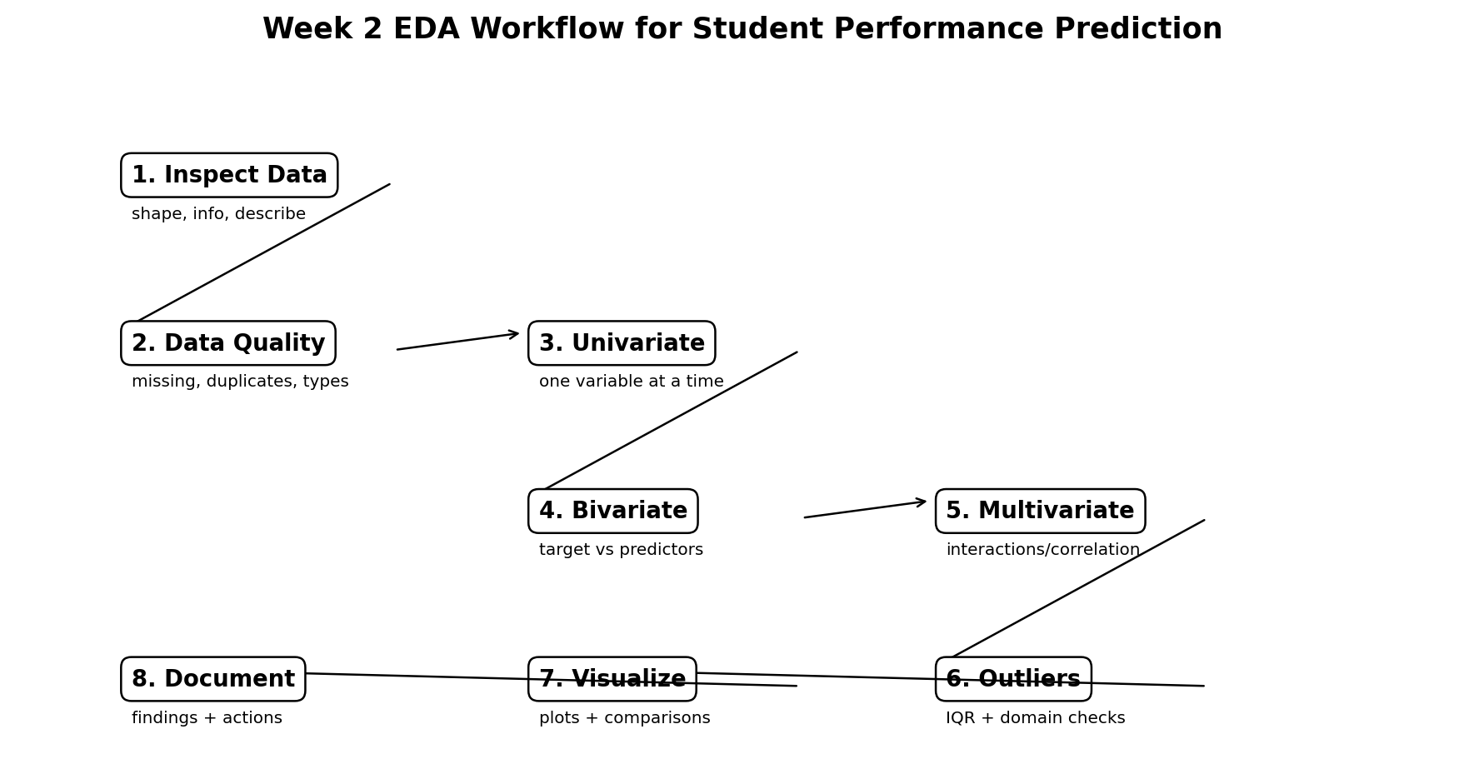
Figure 1. Planned EDA workflow from inspection through documentation.

10. Visualization Strategy
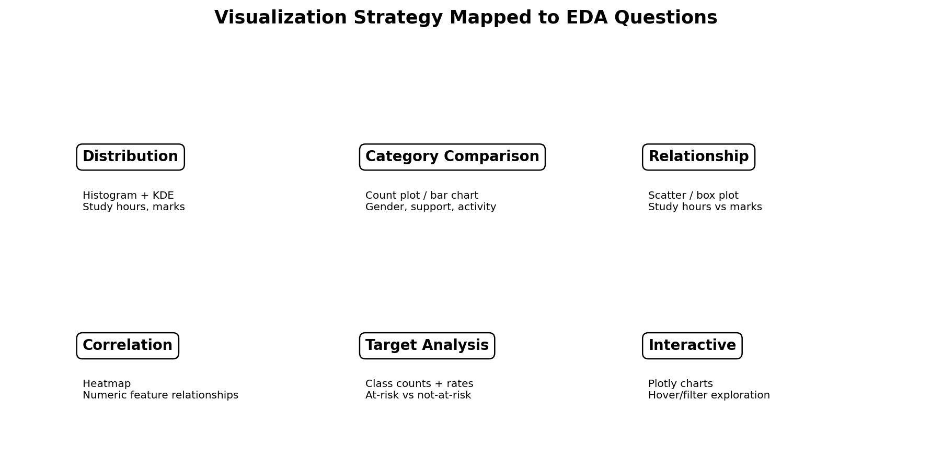
Figure 2. Visualization strategy mapped to common EDA questions.
EDA question | Primary visualization | Secondary check
What is the distribution? | histogram / KDE | box plot
How do categories compare? | bar/count plot | percentage table
How do two numerical variables relate? | scatter plot | correlation coefficient
Which variables move together? | heatmap | pair plot
How does target composition vary? | count/stacked bar | grouped percentage
Do groups have different score distributions? | box/violin plot | summary statistics
Need interactive exploration? | Plotly | hover/filter views

11. Python Tools and Libraries
Tool | Role in project
Pandas | data loading, cleaning, grouping, summaries
NumPy | numerical calculations and array operations
Matplotlib | custom static plots
Seaborn | statistical plots and heatmaps
Plotly | interactive charts
Jupyter Notebook | reproducible EDA workflow and narrative
Scikit-learn | later preprocessing, feature engineering and evaluation
Git/GitHub | version control and documentation

12. Detailed Feature-Engineering Readiness
Week 2 is EDA-focused, but findings will directly prepare later feature engineering. Every derived feature must use only information available at the prediction time.
Candidate feature | Example calculation | Why investigate?
Academic average | (70 + 80) / 2 = 75 | summarizes multiple scores
Assessment gap | 78 − 65 = 13 | captures improvement/decline
Study-effort index | study hours ÷ absences (safe handling) | combines effort and attendance context
Attendance band | 0–59, 60–74, 75–89, 90–100 | tests nonlinear effects
Study-hours band | 0–2, 3–5, 6–8, 9+ | tests threshold effects
Interaction feature | attendance × study hours | captures combined behavior
One-hot encoding | support yes/no → 0/1 | makes categories model-ready

Leakage prevention: future exam results, post-outcome interventions, or information unavailable at prediction time must not become predictors. The final feature list will be reviewed against the defined prediction point.

13. Model Evaluation Readiness
The planned later workflow is: clean → split data → fit preprocessing on training data only → train models → cross-validate → evaluate on an untouched test set.
Illustrative split: with 1,000 records, an 80/20 split produces 800 training rows and 200 test rows. If the illustrative target distribution is 70% Not At Risk and 30% At Risk, stratification would aim for about 560/240 in training and 140/60 in testing.
Example evaluation: if a model correctly predicts 180 of 200 test records, accuracy = 180/200 = 90%. Precision, recall, F1-score, and a confusion matrix will also be reported because identifying at-risk students may be more important than overall accuracy.
Metric | What it measures | Use in project
Accuracy | overall proportion correct | general performance
Precision | correct positive predictions / all positive predictions | reliability of at-risk alerts
Recall | correct positive predictions / all actual positives | how many at-risk students are detected
F1-score | balance of precision and recall | balanced metric
Confusion matrix | TP, TN, FP, FN counts | understand error types
5-fold CV | performance across five training folds | stability during model comparison

14. Reporting and Documentation Plan
Each EDA finding will use the structure Question → Method → Result → Interpretation → Action.
Example entry: Question: Is attendance associated with risk? Method: compare attendance distributions by target using box plots and grouped summaries. Result: calculate the actual difference from the dataset. Interpretation: determine whether the pattern is meaningful and whether outliers distort it. Action: decide whether attendance needs transformation, binning, or an interaction feature.
The final notebook/report will include dimensions, data dictionary, missingness table, duplicate count, outlier decisions, key plots, correlations, target distribution, important relationships, feature-engineering candidates, and limitations.

15. Expected Findings
- Identify the most frequent missing-value fields and quantify their rates.
- Determine whether numerical variables are skewed or contain extreme values.
- Measure target-class balance before selecting evaluation metrics.
- Identify candidate predictors with useful relationships to performance.
- Find redundant or highly correlated features that need review.
- Find feature-engineering candidates without introducing leakage.
- Create a reproducible visual record supporting later model decisions.

16. Challenges and Mitigation
Challenge | Potential impact | Mitigation
Missing values | biased summaries/model inputs | quantify first; choose justified imputation
Outliers | distorted mean/correlation | IQR + box plot + domain validation
Class imbalance | misleading accuracy | stratified split + precision/recall/F1
High correlation | redundant predictors | heatmap + feature review
Data leakage | overly optimistic model | define prediction point; fit transforms on train only
Too many plots | unclear report | tie each plot to a specific EDA question
Small categories | unstable conclusions | report counts and group carefully

17. 32-Hour Week 2 Work Plan
Activity | Hours | Output
EDA planning and data dictionary preparation | 3 | EDA checklist + variable map
Dataset inspection and quality profiling | 5 | shape/types/missing/duplicate report
Univariate analysis | 4 | distribution plots + summaries
Bivariate analysis | 5 | relationship plots + target comparisons
Multivariate analysis | 4 | heatmap/interactions/grouped analysis
Outlier and missing-data strategy | 3 | documented treatment rules
Visualization and notebook formatting | 3 | organized charts + captions
Findings, feature-engineering readiness and documentation | 5 | final EDA report/notebook
Total | 32 | Completed Week 2 framework

18. Feedback-Alignment Checklist
Feedback item | How this revised Week 2 addresses it
Specific examples | Includes 1,000-record examples, 40/1,000 = 4% missingness, 70:30 class balance, 80/20 split, and calculation examples.
Concrete numbers | Includes 4% missingness, 700/300 class example, 800/200 split, 560/240 and 140/60 stratified example, and 90% illustrative accuracy.
Diagrams included in text | EDA workflow and visualization strategy diagrams are embedded directly in the document with captions.
Detailed feature engineering | Covers averages, gaps, bins, interactions, encoding, and leakage prevention.
Detailed model evaluation | Covers evaluation sequence, metrics, confusion matrix concepts, stratification, cross-validation, and untouched test set.
Avoid unsupported claims | All numerical values are clearly labeled illustrative/planning assumptions; actual results will only be reported after dataset analysis.

19. Conclusion
This revised Week 2 framework turns EDA into a measurable and documented process rather than a list of generic plots. It defines what will be checked, which visualization answers each question, how numerical findings will be interpreted, and how EDA outputs will feed into feature engineering and model evaluation.
Important note: All numbers in this document are illustrative planning examples. They are not claimed experimental findings from the final dataset.

